eTwinning Microgrant Scheme

Submission Form

# **School details**

School name*

Shape

School address*

Shape

School Roll Number*

Shape

Please confirm that your school is a school providing general education at pre-primary, primary or secondary level in the Republic of Ireland*

* Yes
* No

Please confirm that your school qualifies as a small school. Small schools are defined as schools with four mainstream teachers or fewer, as outlined by the [Department of Education.*](https://www.gov.ie/en/press-release/36ca7-minister-foley-announces-two-year-extension-of-small-schools-project-to-support-sustainability-of-small-schools-in-rural-ireland/)

* Yes
* No

How did you hear about the eTwinning microgrant scheme?

Please Select:

* + On Léargas' website
  + From Léargas staff
  + Word of mouth
  + Social Media
  + Other
  + Can't remember

Have you previously received funding through Léargas?*

* + DiscoverEU
  + Youth in action
  + Erasmus+ (in the field of youth)
  + Erasmus+ (in the field of schools)
  + Erasmus+ (in the field of VET)
  + Erasmus+ (in the field of adult education)
  + Other
  + No

# **Contact person's details**

First name of the contact person*

Shape

Last name of the contact person*

Shape

Telephone number*

Shape

Email*

Shape

Job/Role in the school*

Shape

**Project details**

Name of eTwinning Microgrant activity*

*Examples of potential activities include workshops, conference, exhibition, mini festival etc.*

Shape

Describe the activity/activities which you seek funding for. Include the specific timeframes. *

*Projects must take place between October-December 24. Max 600 characters*



Briefly describe the group(s) that your activity targets / What is the profile of your participants? *

*Max 600 characters*



Briefly describe how your activity supports the Digital Strategy for Schools priorities. *

*Max 600 characters*

Shape

What do you hope to achieve with this activity? Please describe the anticipated outcomes and impact it will have on teaching and learning in your school. *

*Think about what changes will happen because of your project. Max 600 characters*

Shape

Does this activity support Young People with Fewer Opportunities? If yes, please give details. *

*Max 600 characters*

Shape

How will you ensure your activities are visible? *

*Examples include:*

* *advertising the activity, and that it was funded by Léargas, using our website/newsletter;*
* *telling local radio/newspapers about the activity and that it received funding through Léargas;*
* *writing a blog about the activity to share what we learnt and acknowledging that it received funding through Léargas;*
* *(if a school:) students who took part in the activity speak in an assembly about what they learnt.*

Shape

# **Section C: Funding Requirements**

Grant required (up to €5,000):*

Shape

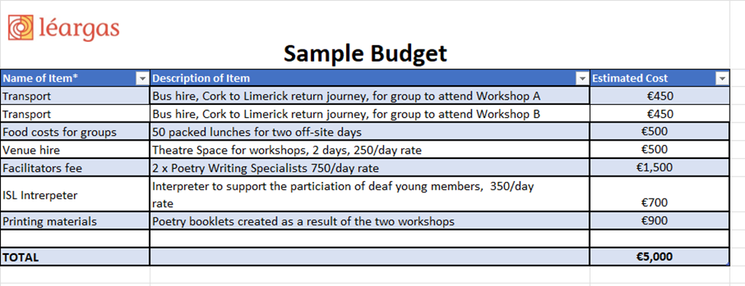

Complete [this budget template](https://www.leargas.ie/wp-content/uploads/2024/09/eTwinning-Microgrant_2024_Budget_Template.xlsx) with details of your estimated budget.

*Potential items could include: venue hire; transport (including milage rate of 39c per km); refreshments; accommodation; resources; materials; branded promotional materials; exceptional costs for participants with fewer opportunities; and so on.*

*Costs that will not be eligible include IT equipment (such as laptops or iPads); staff costs that are usually incurred by the activity of the applicant; usual operational overheads such as utilities or rent of premises for usual work of organisation.*

*Once off fees that are specific to the eTwinning Microgrant Activity may be eligible, however, costs normally incurred by the organisation are not eligible.*

* *E.g. Fees for once off trainers/facilitators/speakers/coaches specific to the eTwinning Microgrant activity may be eligible, however, the organisation's normal staffing costs are not eligible.*
* *E.g. Fees for renting a venue specifically for the eTwinning Microgrant activity may be eligible, however, costs (e.g. rent) associated with the organisation's normal venue are not eligible.*

Léargas is committed to protecting and respecting your privacy, and we’ll only use your personal information to administer your account and to provide the information and resources you requested from us. We would like to contact you about other opportunities, as well as content that may be of interest to you. If you consent to us contacting you for this purpose, please tick below to say how you would like us to contact you.

* I agree to receive other communications from Léargas.

You can unsubscribe from these communications at any time. For more information on how to unsubscribe, and how we are committed to protecting and respecting your privacy, please review our Privacy Policy.

By submitting this document, you consent to allow Léargas to store and process the personal information submitted above to provide you the content requested.